**Title**

Proponent

**Notre Dame of Marbel University**

**MIT 265 – Advanced Software Engineering**

Brenda M. Balala, MIT

March 2025

**Table of Contents**

Contents

Introduction 4

Background of the Study 4

Statement of the Problem 4

Objectives of the Study 5

Concept of the Study 6

Conceptual Framework 7

System Architecture 8

Data Flow and Processing 8

Security and Authentication 8

Deployment and Scalability 8

Methods 9

Hardware 9

Software 9

Frontend 9

Backend 9

Database 9

Procedures 10

Design Methodology 10

Development Model 11

Requirements Analysis 11

Functional Requirements 11

Non-Functional Requirements 11

Requirements Documentation 12

System Use Case diagram 12

User Stories 12

Acceptance Criteria 12

System Design 12

# Introduction

The introduction provides an overview of the study, its background, objectives, and key components that will be explored in the research. This section establishes the foundation for the entire study, helping readers understand the problem being addressed, the motivation behind the study, and the methodologies to be used.

## Background of the Study

* *Describe the history of how you developed the idea for your project*
* *Include information about the reasoning why you want to implements this specific software development. Explain the current situation and its problems and the way in which you want to solve these problems.*

Sample:

The retail landscape has witnessed a remarkable transformation in recent years, with the advent of e-commerce and the increasing shift toward online shopping. This shift is fueled by changing consumer behaviors, a desire for convenience, and the ease of access to a wide range of products. The fashion and footwear industry is no exception to this trend, as consumers seek stylish and comfortable footwear choices without leaving the comfort of their homes.

Our study is focused on the development of an online shopping platform tailored to meet the specific needs of a brick-and-mortar shoe store, "ShoeStyle Boutique." ShoeStyle Boutique has been a trusted provider of high-quality footwear for over a decade, with a reputation for offering a wide selection of shoes catering to diverse customer preferences.

The motivation behind this study is rooted in the recognition of the growing demand for online shopping and the need for ShoeStyle Boutique to expand its presence in the digital marketplace. While the store has established a loyal customer base through its physical locations, it has identified the opportunity to tap into a broader customer demographic by venturing into e-commerce. This transition aligns with the broader retail industry trend, where online sales have been steadily on the rise.

Sample:

The Online Shopping Platform (OSP) is designed to provide a seamless e-commerce experience for customers and vendors. It enables users to browse, search, and purchase products, while vendors can list and manage inventory. The system integrates secure payment gateways, user authentication, and advanced recommendation algorithms.

.

## Statement of the Problem

* *Introduce the presentation of the problem, that is, what the problem is all about.*
* *This section presents the specific problems the study intends to solve. The problem statement should be precise and directly related to the solution being proposed.*
* *The existence of an unsatisfactory condition; is a felt* ***problem that needs a solution****. A solution that involves the development of system software.*
* *The proponent should give a strong justification for selecting such a software development problem and the desire and concern to improve the system.*

Example:

1. Limited Market Reach: The shoe store's physical location restricts its market reach to local customers, hindering potential sales from a broader regional and national audience.
2. Inefficient Inventory Management: The absence of a digital platform hinders the efficient management of shoe inventory, leading to challenges in tracking product availability, restocking, and sales analytics.
3. Customer Convenience: In an increasingly digital world, customers expect the convenience of browsing and purchasing shoes online. The absence of an online platform limits the shopping options available to potential customers.
4. Competitive Disadvantage: Competing shoe retailers have established online platforms, giving them a competitive edge. The lack of an online presence puts the shoe store at a disadvantage.
5. Data-Driven Decision-Making: The store lacks the data and analytics that an online platform can provide for decision-making, including insights into customer preferences and shopping trends.

Example:

1. Inefficient product discovery and filtering mechanisms
2. Security concerns in online transactions
3. Limited scalability on existing platforms.
4. Poor integration of user feedback and recommendation systems.

## Objectives of the Study

* *Start with the General Objective which is very parallel to the project title.   
  - Break down the general objective into Specific Objectives that will help realize the proposed study.*
* *Objectives should be SMART*

Example:

General Objective:

The general objective of this study is to develop and implement an online shopping platform for the shoe store to expand its market reach and enhance customer engagement.

Specific Objectives:

1. To create an online shopping platform that provides customers with a user-friendly interface for browsing and purchasing shoes.
2. To establish an efficient inventory management system that tracks product availability, restocking needs, and sales analytics.
3. To improve customer convenience by offering an online shopping experience that includes product descriptions, images, and online payment options.
4. To enhance the shoe store's competitiveness by establishing an online presence and reaching a broader customer base.

These specific objectives aim to address the identified problems and create a successful online shopping platform for the shoe store, ultimately improving its market reach and customer satisfaction.

## Concept of the Study

*In this section, the core technologies and design principles used in the study are introduced. This includes the architecture (e.g. microservices), technologies (e.g. React.js, Node.js) and security mechanisms (e.g. OAuth 2.0, JWT)*

*The conceptual framework presents the relationship between the specific concepts that may be studied.*

*Guides the project development in determining what things you will measure.*

*Do not limit to Input-Process/Throughput-Output (IPO)*

*Provide a single diagram that provides a one-glance summary of the totality of*

*your work – the concept of the study, phases, data, input, output, software, hardware, approach, etc. must be seen in the diagram (Think of this as a more comprehensive system architecture)*

*The software architecture of a system represents the design decisions related to overall system structure and behavior. Architecture helps stakeholders understand and analyze how the system will achieve essential qualities such as modifiability, availability, and security.*

## Conceptual Framework

The conceptual framework illustrates the components of the system and how they interact. It illustrates and explains the structure, flow, and interaction of the system’s components. It focuses on how different parts of the system interact, including architecture, data flow, security and deployment. It helps visualize the system’s structure and operations.

Example:

Figure1 Conceptual Framework

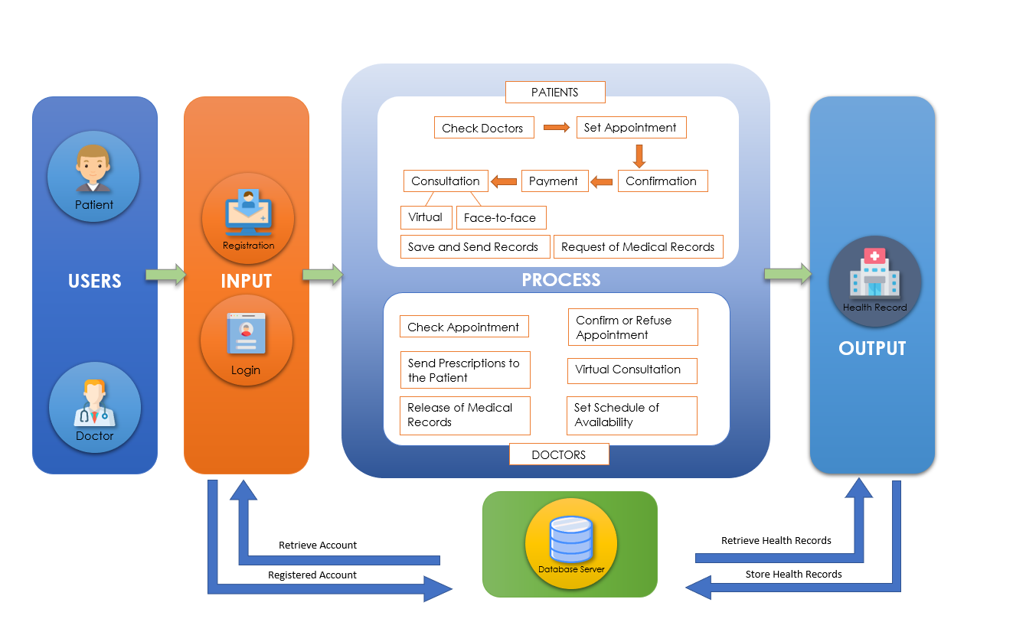

*Describing content in the figure would appear here*

Users

There are two types of users; the doctor and the patient. Users must first create an account before they can access the main system. They can now access the entire system after creating an account.

Input

Users will register their accounts, which will be saved on the database server, and they will be able to retrieve them by logging in to their accounts to use the system.

Process

The process is divided into two modules: the patient's module and the doctor's module. Patients can check whether doctors are available for their specific illnesses in the patient's module. Following that, the patient can make an appointment with their preferred doctor and select their preferred date and time from the doctor's schedule and patients will have the option of having a virtual or face-to-face consultation. After scheduling an appointment, the confirmation page will appear, allowing the patient to double-check the information and schedule. Afterward, if the patient chose a virtual consultation, the patient will pay via Gcash to complete the transaction, and if the patient chose a face-to-face consultation, the patient can pay via Gcash or in the doctor's cashier in the clinic. Finally, there is the consultation, which is divided into two parts: virtual and face-to-face. Patients can also send and save medical laboratory results, as well as request medical records. For the doctor’s module, the doctors can check the appointment of the patients, then they can confirm or refuse the appointment set by the patients. Also, the doctors can send prescriptions to the patient. If the patient requests a virtual consultation, the doctor will be directed to Google Meet to generate a link. If the patient requests it, doctors can also release medical records and the doctor can schedule his or her availability.

Output

The output will be the patient's health records as created by the doctor. The records will be saved in a database and can be retrieved at any time by doctors or patients.

### System Architecture

* Diagram or description of the microservices-based architecture
* Explanation of how different services (e.g. product management, user authentication) communicate and interact.

### Data Flow and Processing

* Description o how data flows through the system, from user input to database storage.
* Diagram to represent data flow.

### Security and Authentication

* Overview of security measures (e.g. OAuth 2.0, JWT, data encryption)
* Authentication flow and mechanisms from ensuring secure transactions.

### Deployment and Scalability

* Explanation of deployment methods (e.g. AWS, Kubernetes)
* Scalability considerations (e.g. horizontal scaling of microservices)

# Methods

## Hardware

* *Specifications of the hardware used*
* Asus Vivo Book Intel i5, 8gb DDR4 RAM, Nvidia 940MX
* Desktop Intel i7, 16GB DDR4 RAM, Nvidia RTX 3060

## Software

* *Software used in the design and development of the system. Discuss how the software is used.* ***DO NOT*** *give the definition of the software*
* Microsoft Visual Studio
* Sublime Text
* XAMPP
* phpMyAdmin

### Frontend

* Technologies used for the frontend (e.g. React.js, Next.js)
* Key considerations for responsive design and user experience

### Backend

* Description of backend technologies (Node.js, Express.js)
* Explanation of microservices architectures and RESTful APIs.

### Database

* Overview or relational (PostgreSQL and NoSQL (MongoDB) databases
* Why both types are used form different purposes (structured vs unstructured data)
* *Sources and composition of data*

# Procedures

This section describes the process of system development, from design to implementation.

* *Must be sequential based on the Conceptual framework*
* *Indicate the various steps that must be taken to attain the Specific Objectives*

## Design Methodology

* *provides a logical and systematic means of proceeding with the design process as well as a set of guidelines for decision-making. The design methodology provides a sequence of activities, and often uses a set of notations or diagrams.*
* *Create a diagram of the methods to be used in software development based on the* ***Specific Objectives***
* *Example: SDLC, Web Development Life Cycle, Game Development Life Cycle*

Example

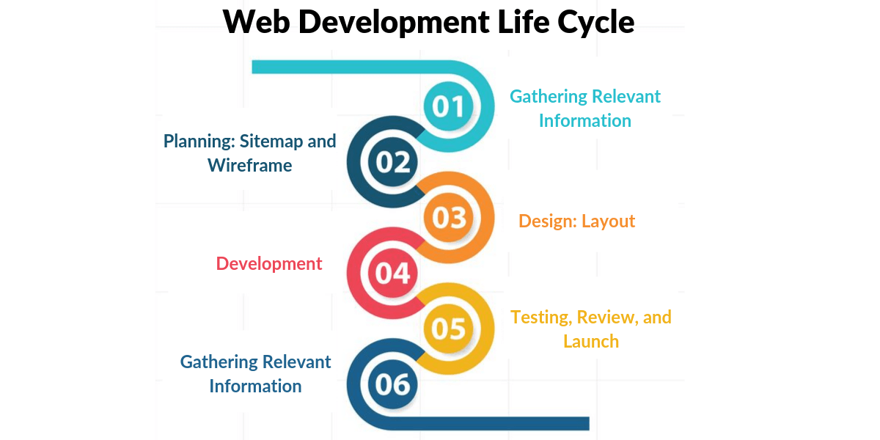Figure 2 Web Development Life Cycle

## Development Model

* *The model to be used in the development of the system*
* *Discuss the activities done in each stage.*
* *Explanation of the agile or waterfall development model adopted for the project.*
* *Iterative development cycles with milestones and reviews.*

## Requirements Analysis

* *Discuss the details of the current system (how the current procedures are performed)*
* *Create a* ***USE case diagram of the current system***

### Functional Requirements

* Functional features of the platform (e.g. user login, product search, shopping cart, checkout)

### Non-Functional Requirements

* High-level system performance and scalability goals

Example of goals:

* High Availability and Fault Tolerance – techniques used to ensure the platform is always accessible
* Scalable Architecture to Support High Traffic
* Compliance with Payment Card Industry Data Security Standard(PCI DSS)

### 

## Requirements Documentation

* *All software features are enumerated in detail by providing storyboard showing how the proposed system will look like.*
* *Requirements documentation is the description of what a particular software does or shall do. It is used throughout development to communicate how the software functions or how it is intended to operate. It is also used as an agreement or as the foundation for agreement on what the software will do. Requirements are produced and consumed by everyone involved in the production of software, including:  end-users, customers, project managers, sales, marketing, software architects, usability engineers, interaction designers, developers, and testers.*

### System Use Case diagram

* Diagram representing system use cases, including interactions between users and the system

### User Stories

* User stories detailing the needs of different user personas (e.g. buyer, vendor, admin)

### Acceptance Criteria

* Criteria used to determine if the system meets the requirements (e.g. response time, error rates)

## System Design

### Architectural Design

* ***Detailed breakdown of system components: frontend, backend, database, and security***

### Database Design

### Application Flow

* ***,***